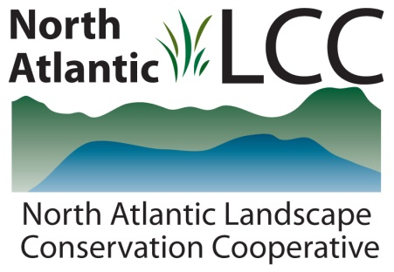

Connecticut River Watershed Landscape Conservation Design Pilot

Project Name | Habitat suitability modeling of select Regional Species of Greatest Conservation Need (RSGCN)
Product Type | Model output raster comprised of a continuous gradient of habitat suitability. Supporting documentation primarily consisting of metadata that describes the modeling methods, input environmental parameters, and possible uses and limitations of the model.
Product Description | A subset of RSGCN will be modeled to identify areas of potential habitat suitability within the northeast region (USFWS region 5). Species will be selected based on the quality of population point occurrence data for the species’ known range within the northeast, level of regional concern and responsibility in the context of the overall species range, and other relevant factors. Species models will be developed in close consultation with teams of species biologists organized by taxonomic specialty, using one or more presence-only or empirically-based modeling methods.
Geographic Extent and data scale | 13-state northeast region. Habitat suitability models could potentially extend into Canada on a by-species basis pending the availability of coverage of the selected environmental variables within the Canada portion of the LCC)
Developer | North Atlantic Landscape Conservation Cooperative
Contact | Lori Pelech and Steve Fuller
Completion | Before the end of 2014

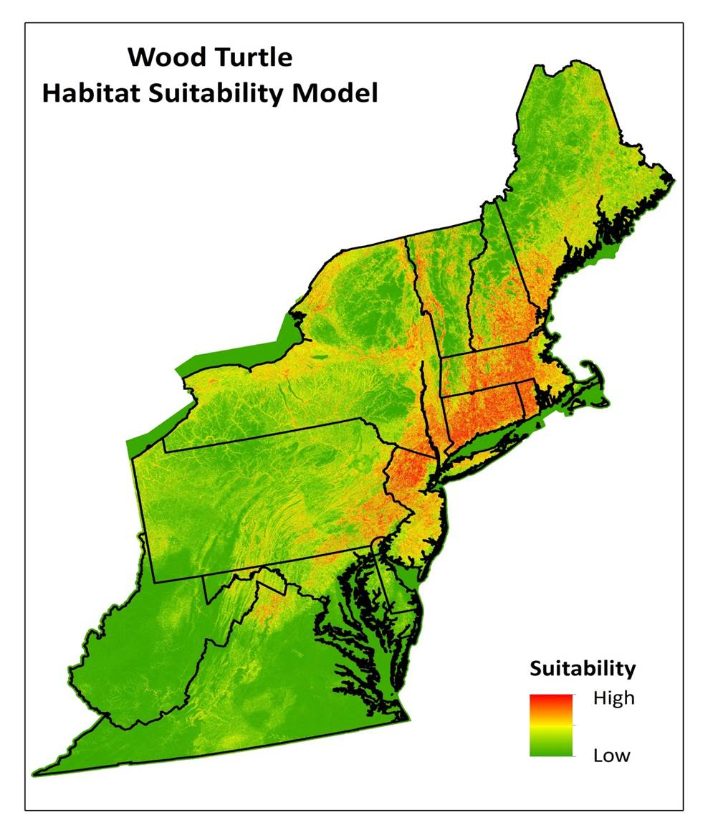
Example Illustration of a Habitat Suitability Model

