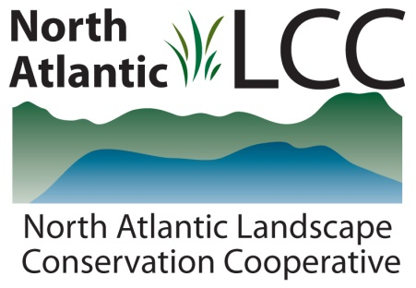

Connecticut River Watershed Landscape Conservation Design Pilot

Project Name | Designing Sustainable Landscapes – Ecological Integrity
Product Type | GIS datasets that depict the ecological integrity of Northeast landscapes
Product Description | The datasets depict the ecological integrity of areas throughout the northeastern United States based on both current conditions and scenarios of potential future conditions. Future conditions include scenarios of potential future climate, urban growth (development), and forest change. The product includes datasets that depict how and where ecological integrity may change due to future landscape change.  Ecological integrity is defined as the ability of an area (e.g., local site or landscape) to sustain important ecological functions over the long term. In particular, the functions include the ability to support biodiversity and the ecosystem processes necessary to sustain biodiversity over the long term. Ecological integrity is measured using a suite of landscape metrics, including:  - Intactness – the freedom from human impairment (anthropogenic stressors), measured as a combination of a number of stressor metrics  - Resiliency – the capacity to recover from disturbance and stress, measured as a combination of the connectedness and similarity to neighboring natural areas  Ecological integrity is expressed on a relative scale (0 to 1) for each ecological system mapped on the Northeast Terrestrial Habitat Map developed by the Nature Conservancy and the northeastern states. Ecological systems are recurring groups of biological communities found in similar environments at scales from tens to thousands of acres and typically persisting for 50 or more years. Examples of the more than 100 mapped systems include “Acadian-Appalachian Montane Spruce-Fir Forest” and “Northern Atlantic Coastal Plain Tidal Salt Marsh.”
Geographic Extent and data scale | The geographic extent is the region covered by the thirteen northeastern states. The resolution is 30 m cells.
Developer | Department of Environmental Conservation  University of Massachusetts Amherst
Contact | Professor Kevin McGarigal
Completion | 2014

Example of the index of ecological integrity (IEI) mapped for New England based on current conditions (circa 2010).
